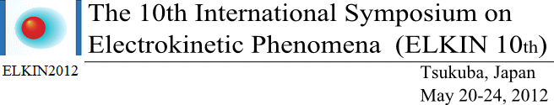
REGISTRATION FORM for DOMESTIC
Please fill in this form and return by e-mail to elkin12@envr.tsukuba.ac.jp
with e-mail subject : “ELKIN2012 registration request”
お手数をお掛けしますが英語、日本語両方の情報をご記入お願いいたします．

REGISTRATION
TITLE: Prof. / Dr. / Mr. / Ms.
FIRST NAME:
SURNAME:
氏名:
AFFILLIATION:

DEPARTMENT:

所属機関・部署:

ADDRESS:

住所:

POSTAL CODE:
PHONE:
FAX:
E-MAIL:

NAME OF ACCOMPANYING PERSON (S) (IF ANY):

PAYMENT
Please indicate your registration choice by ticking the appropriate box.
☐ ORDIANY ☐ STUDENT *
☐ ACCOMPANYING PERSON ( 0 x Person(s))
BANK TRANSFER
三井住友銀行 つくば支店(244) 普通 0203898
ＥＬＫＩＮ２０１２日本委員会 代表 足立 泰久
(ｴﾙｷﾝﾆﾏﾙｲﾁﾆﾆﾎﾝｲｲﾝｶｲ ﾀﾞｲﾋﾖｳ ｱﾀﾞﾁ ﾔｽﾋｻ)
振込日（予定）: MM / DD / YYYY
WELCOME RECEPTION
☐ 参加 ☐ 不参加
（費用は参加費に含まれています）

Note: * Please send a copy of your valid student card with this form.

REMARKS:

Registration fees | Before Feb. 29th, 2012 | After Mar. 1st, 2012
Normal | 50,000 yen | 60,000 yen
Student | 25,000 yen | 30,000 yen
Accompanying Person | 20,000 yen | 20,000 yen

